Proposal #1

Platformer game
Jump around on platforms going higher and higher with power ups along the way

Jumping, gravity, collisions

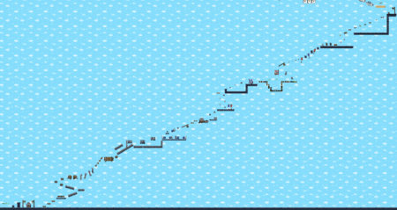

Proposal #2

Top down shooter game
Shoot enemies coming from around the screen that are shooting back, Have the ability to unlock new weapons
Path tracing, Directing the bullets towards the player, particle explosions,
Class particle, Encapsulation, Color and transparency (fill(), stroke(), alpha) — for visual polish.
Particle systems
Screen shake or glow effects
Millis()
atan2()
PVector.sub(mouse, player)
PVector — for position, velocity, and direction math
(This simplifies movement and aiming.)
PImage — for loading sprites or backgrounds
colorMode(HSB) — for flashy effects
dist(), atan2(), cos(), sin() — for directional shooting, rotation, and geometry
translate() + rotate() — to rotate ships or effects
pushMatrix() / popMatrix() — to isolate transformations
Trails and fading effects
- Transparent rectangles over the screen for afterimages
- Storing previous positions to draw trails
Particle effects
- Small fading particles on explosions or movement
· Managing ArrayLists

Adding/removing elements mid-loop causes errors or bugs.

Iterate backward or use for (int i = list.size()-1; i >= 0; i--).
Use colorMode(HSB, 360, 100, 100, 100); and lower the alpha on the fill (like 10–30) for smoother glowing fades.
You can animate the hue of each trail segment for a rainbow streak effect (fill((frameCount + i * 10) % 360, 100, 100, alpha)).
3. Particle System Trails
Instead of reusing positions, spawn tiny particles that fade and drift behind moving objects.
Each particle:
- Has a short lifespan
- Fades alpha over time
- Maybe moves a little randomly (vel.add(PVector.random2D().mult(0.1));)
This looks more organic than simple trails — like sparks or plasma.
1. Color and Contrast
- Use HSB color mode for easy hue variation and glow effects.
- colorMode(HSB, 360, 100, 100, 100);
- Keep the background dark and your bullets/enemies bright — instant contrast and visual clarity.
- Consider hue-shifting your bullets or player as they move.
· 3. Screen Shake (Juice)
· After a big explosion or when the player gets hit, shake the camera slightly:
· float shake = 10;
· translate(random(-shake, shake), random(-shake, shake));
· (Reset with pushMatrix() / popMatrix() around your drawing code.)

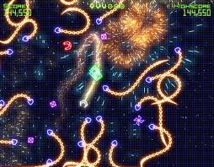
vel = PVector.fromAngle(angle);
Using atan2() to aim towards the mouse.
Using sin() and cos() to set directions and rotations.
Add particle trails and explosions.
Add glowing or color effects.
Add sound effects (minim library).
Create start screen / game over screen with restart button.
Optimize (remove off-screen bullets, limit FPS, clean code).

Goals (11/4)
Start creating classes for players, bullets and enemies. Figure out how color mode HSB works, look at examples on how to make the bullet shoot where the mouse is.

Today I accomplished:
Shooting the bullet in the direction of the mouse.
Adding glows and trails using color mode HSB.

Problems I encountered:
Importing an image.

Notes for next class:
Add offscreen and bouncing/boundary logic.

Goals (11/6)
Create class enemy
Figure out how to make the enemy shoot bullets in the direction of the player.

Today I accomplished:
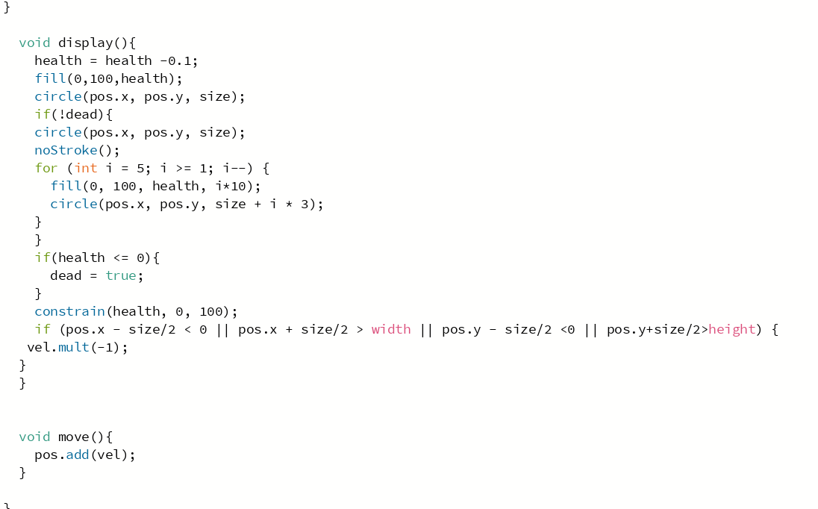
I made the enemies follow the player and bounce off walls and die after a while.

Problems I encountered:
I need to create a bouncing bullet class that extends the bullet class.

Notes for next class:
Create that subclass and figure out the error.

Goals 11/10

Create reactive trails for the player

Today I accomplished:

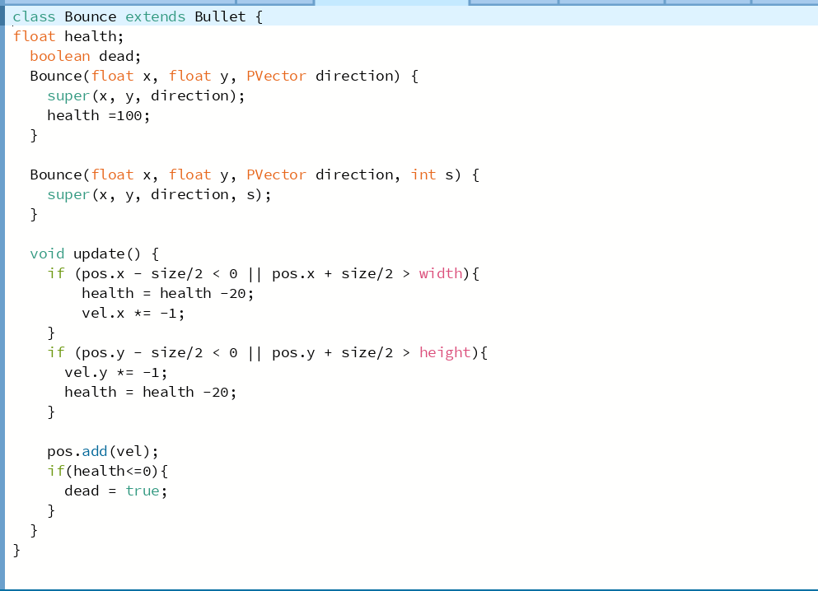
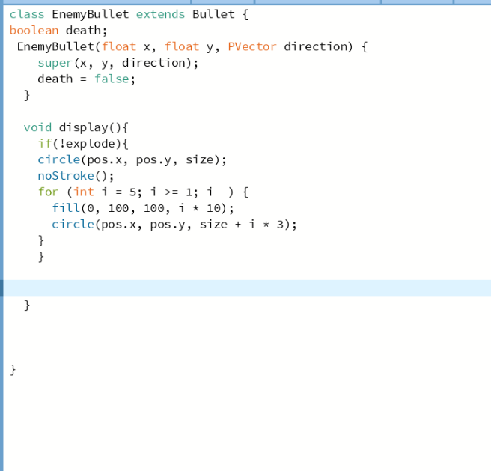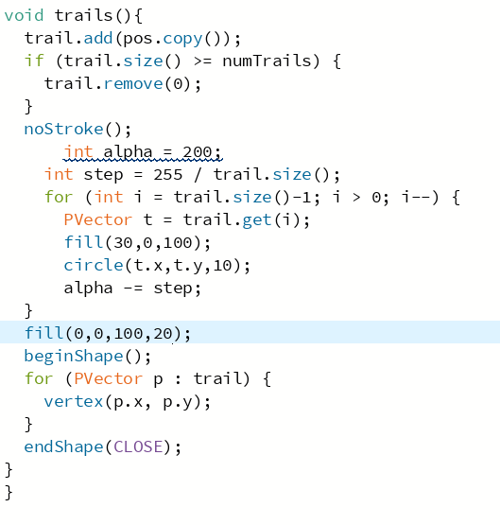
I continued to add different features for the game.

Problems I encountered:
Finding out a way to check the intersection between a polygon and circles.

Goals for next class
Find a way to check the intersection between a polygon and circles.

Goals for 11/12

Check the intersection between a polygon and circles

Accomplishments:
I added more functionality (Screenshots below).

Problems: PVector dir for class grenade

Goals for next class Intersection between polygon and circle+ Pvector dir
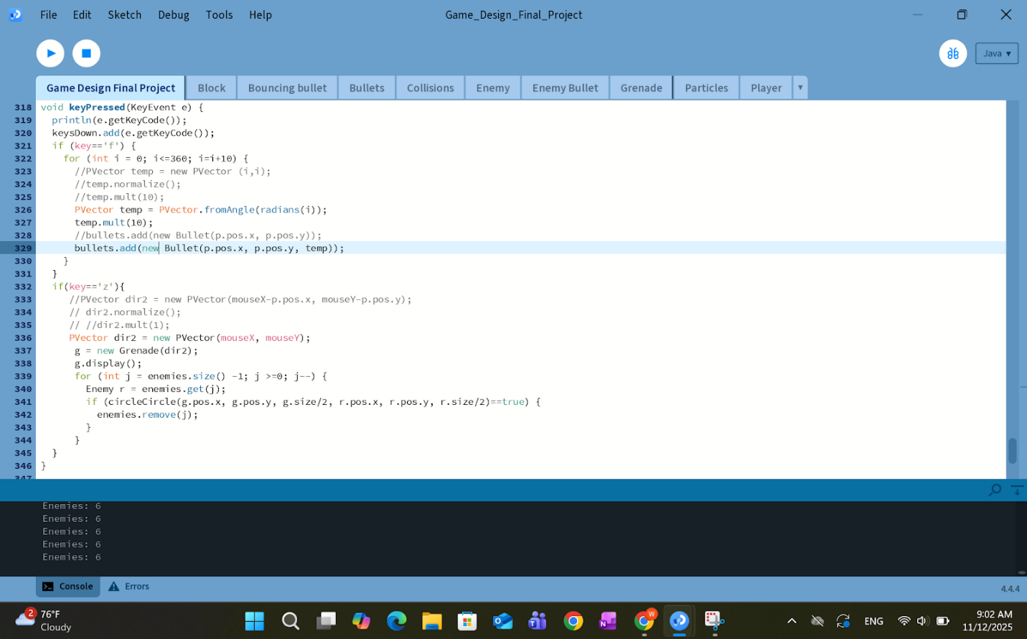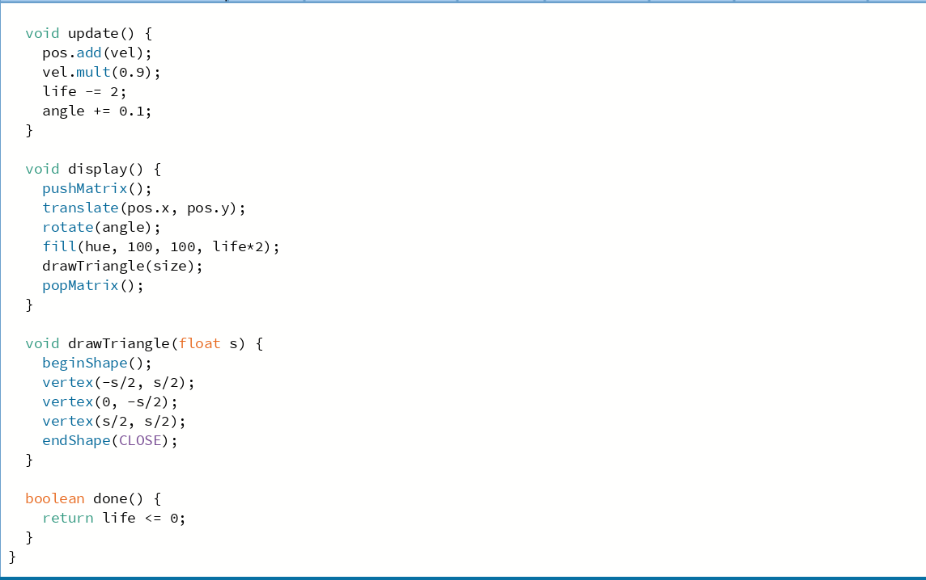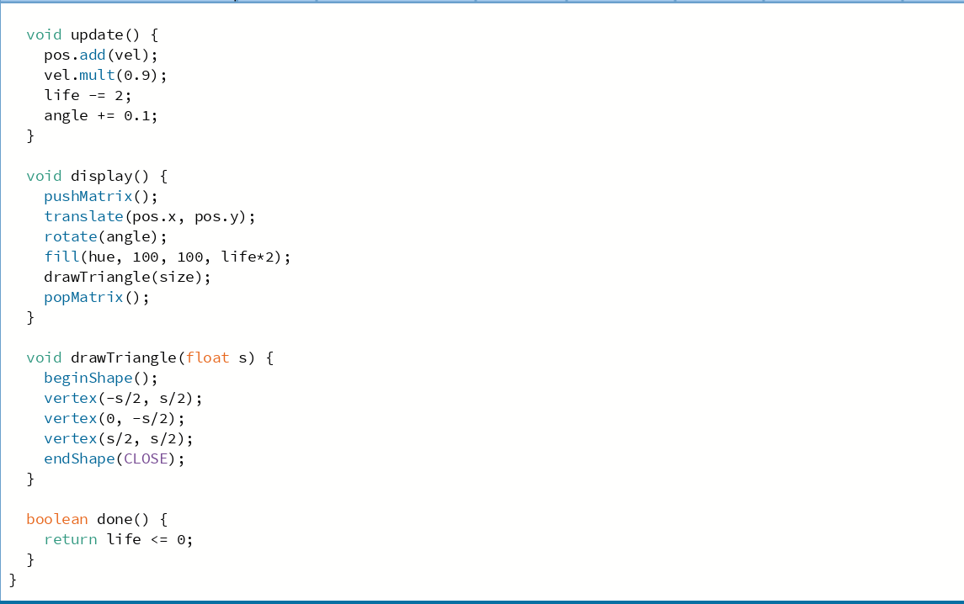
Goals for 11/18

Check the intersection between a polygon and circles

Accomplishments:
I added more functionality (Screenshots below).

Problems: null pointer exception, add collisions for all classes.

Goals for next class Intersection between polygon and circle+ Pvector dir
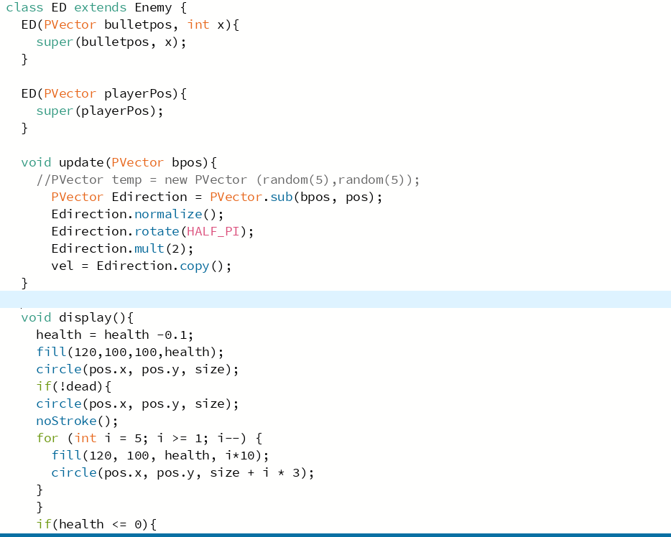
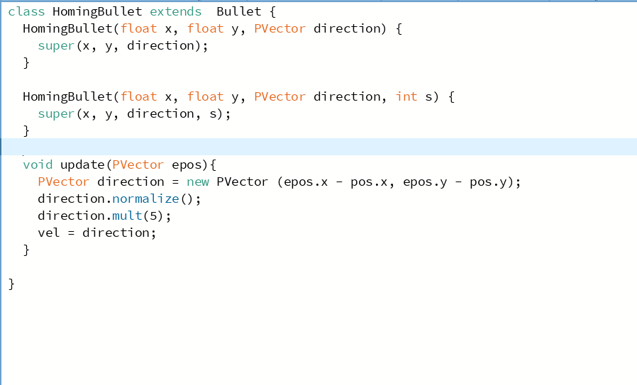
Goals for 11/18

Check the intersection between a polygon and circles

Accomplishments:
I added more functionality and fixed some issues.(Screenshots below).

Problems: add collisions for all classes.

Goals for next class Intersection between polygon and circle+ Pvector dir
Goals for 11/18

Check the intersection between a polygon and circles

Accomplishments:
I added more functionality (Screenshots below).

Problems: null pointer exception, add collisions for all classes.

Goals for next class Intersection between polygon and circle+ Pvector dir

